Entity Relationship Diagram

, Picture

# Structure chart

1. **Customers**

, Picture

1. **Teams**

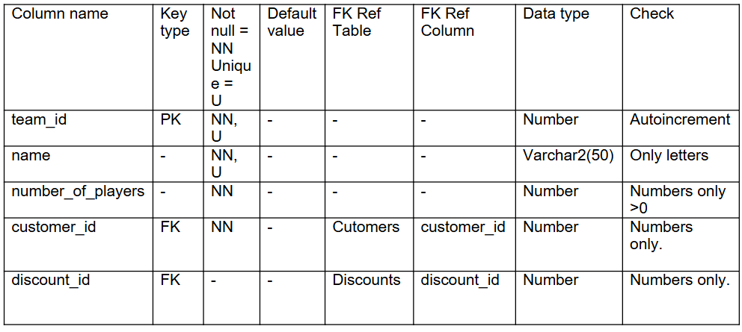

1. **Products**

, Picture

1. **Orders**

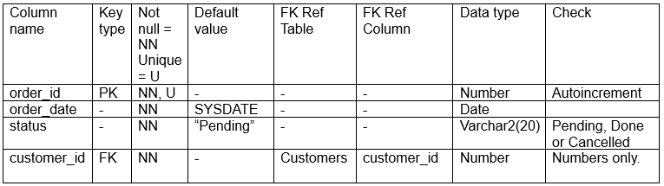

1. **Order** **Products**

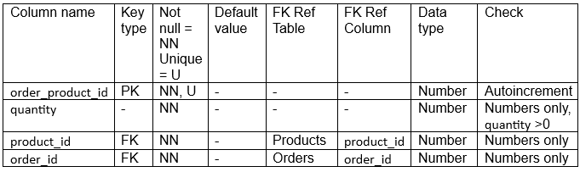

1. **Discounts**

, Picture

1. **Complaints**

, Picture

1. **Sales representatives**

, Picture

1. **Inventory lists**

, Picture